Exercise 21-2 Add a button to a GUI

In this exercise, you’ll add a Clear button to the GUI version of the Future Value Calculator. When you are finished with this exercise, your application should look like this:

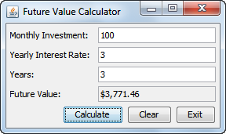

Review the application

1. Open the project named ch21_ex2_FutureValue.
2. Review the code in the FutureValueFrame class.
3. Run the application to make sure it works correctly.

Add a Clear button

1. Declare a private instance variable for a JButton component for the Clear button.
2. In the initComponents method, add the code that creates the button and adds it to the frame.
3. Add an action listener to the Clear button. This action listener should set the text for each text field on the frame to an empty string.
4. Run the application to make sure it works correctly. After you make a calculation, you should be able to click the Clear button to clear the text from all text fields on the frame.